2026 County Budget Workshops

Join DLG Staff as they provide budget information and answer questions to prepare county officials for best practices in budget preparation and management. The workshops are designed for newly elected officials, as well as a refresher course for veteran office holders. Each DLG workshop will provide three (3) hours of HB 810 training credits for those participating.
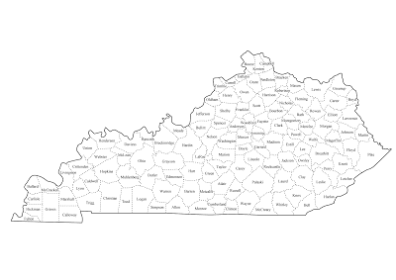
Pre-registration is required to help staff plan for allotted space and materials.
REGISTER HERE
Workshop Schedule:
9 a.m. – Noon – DLG Budget Workshop (Local Time)

Dates & Locations:
2/4/26 Lake Cumberland ADD LCADD Offices, Russell Springs
2/5/26 Kentucky River ADD KRADD Offices, Hazard
2/10/26 Northern Kentucky ADD NKADD Offices, Florence
2/12/26 Bluegrass Region KYTC Conference Center, Frankfort
2/17/26 Lincoln Trail ADD LTADD Offices, Elizabethtown
2/18/26 Green River ADD GRADD Offices, Owensboro
2/19/26 Barren River ADD BRADD Offices, Bowling Green
2/27/26 FIVCO ADD FIVCO Offices, Grayson
3/3/26 Purchase ADD PADD Offices, Mayfield
3/4/26 Pennyrile ADD PADD Offices, Hopkinsville



